**OFFICIAL COORDINATION REQUEST FOR**

**NON-ROUTINE OPERATIONS AND MAINTENANCE**

**COORDINATION TITLE-** 23 IHR 04 – Unit 3 commissioning

**COORDINATION DATE-**  May 2, 2023

**PROJECT-** Ice Harbor Dam

**RESPONSE DATE-** April 25, 2023

**Description of the problem**

The replacement of the runner in unit 3 is nearing completion. Commissioning of the unit involves performing a wide array of tests, including the bump test, bearing heat run tests, governor tuning, unit synchronization, load rejection tests, and 72-hour run. Many of these tests will involve running the unit at various speeds, including occasionally outside of the 1% operating efficiency range, over a period of two weeks. During the 72-hour run the unit will be operating within the 1% range. Testing is scheduled to be performed during 12-30 May, 2023.

**Type of outage required**

**Impact on facility operation** (FPP deviations)

Operating unit 3 out of priority and periodically running the unit above and below the 1% operating efficiency range.

**Impact on unit priority**

The May 1 STP forecast for the period of testing is for roughly 100 to 115 kcfs of inflow to the project. At this level of river flow, one unit will be operating to provide minimum generation while the rest of the water is spilled for fish passage (125% gas cap spill is estimated to be ~110 kcfs). Unit 3 will be generating power during the load rejections tests and 72-hour run. When unit 3 is providing minimum generation, it will be the only unit running at the forecasted flows, meaning unit 3 will be run out of priority ahead of units 1 and 2. When unit 3 is not producing power during testing, unit 1 will also be operating for minimum generation. If river flows are higher than forecast, flows above the 125% gas saturation would require additional units to run and unit priority deviations would be less of an issue.

**Impact on forebay/tailwater operation**

No impacts are expected.

**Impact on spill**

Spill may be reduced by the amount of waterrun through unit 3 for commissioning beyond what is used for minimum generation for brief (less than 60 minutes) periods.

**Dates of impacts/repairs**

The commissioning period is scheduled for 12-30 May. The testing will not necessarily be occurring every day during this period. The dates may shift if there are delays in work completion leading up to commissioning.

**Length of time for repairs**

See paragraph above.

**Analysis of potential impacts to fish**

1. 10-year average passage by run during the period of impact for adults and juvenile listed species, as appropriate for the proposed action and time of year;

The commissioning may be occurring during the peak of the smolt migration for yearling chinook, steelhead, and sockeye (see graph below for yearling chinook passing Lower Monumental Dam).

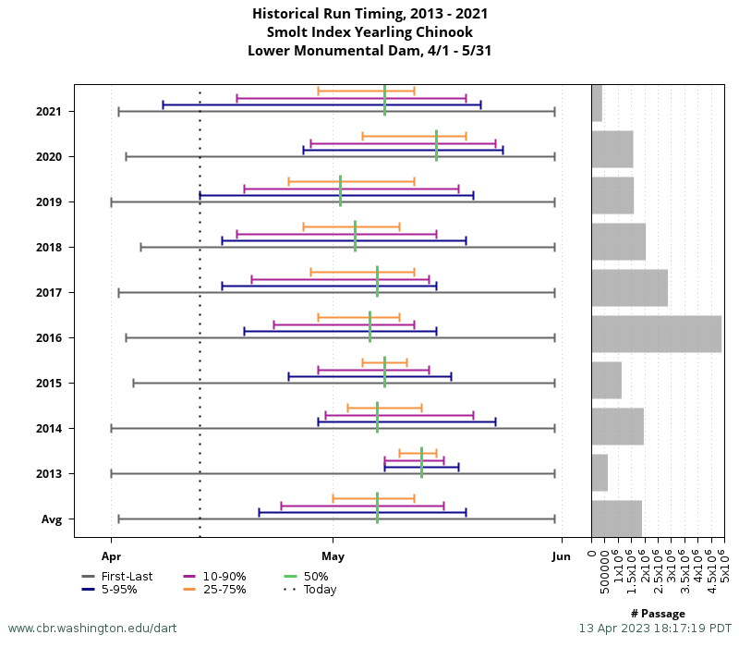

Adult spring Chinook passage will likely be increasing through the test period. (See graph below).

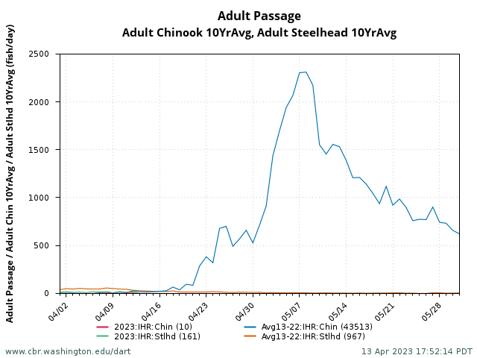

1. Statement about the current year’s run (e.g., higher or lower than 10-year average);

The current run of adult spring Chinook counted so far at Ice Harbor has been below the 10-year average.

1. Estimated exposure to impact by species and age class (i.e., number or percentage of run exposed to an impact by the action);

On average, about 32% of the spring/summer Chinook salmon run passes Ice Harbor Dam 12-30 May.

During typical years, a significant amount, up to about 50%, of the smolt migration occurs during the test period.

1. Type of impact by species and age class (increased delay, exposure to predation, exposure to a route of higher injury/mortality rate, exposure to higher TDG, etc.);

Smolts and adult fallback fish passing through Unit 3 may experience lower survival when Unit 3 is run out of the 1% operating efficiency range. During current spill operations, most fish will pass downstream through the spillway and most fish entering the unit would be bypassed to the river.

Upstream migrating adult fish may experience some passage delay in locating the south shore entrance with Unit 3 operating out of priority. However, analyses of adult fish passage data at the south fish ladder indicated there was no significant difference in fish passage relative to unit 1 or unit 3 operating singly (Trumbo et al. 2014).

**Summary statement - expected impacts on:**

**Downstream migrants**

The impacts should be minor as only a small fraction of downstream migrants will pass through Unit 3 turbine. Brief reductions in spill volume may slow travel times slightly for fish moving downstream.

**Upstream migrants (including Bull Trout)**

Minimal. Adult migrants may experience some passage delay from operating Unit 3 out of priority. Few bull trout have been observed using the fish ladders during the last 10 years.

**Lamprey**

Juvenile lamprey are usually moving downstream in large numbers during the spring runoff, but the impact may be minor, similar to the effect on smolt passage. Few adult lamprey pass the dam in the spring.

**Comments from agencies**

**Final coordination results**

**After Action update** (After action statement stating what the effect of the action was on listed species. This statement could simply state that the MOC analysis was correct and the action went as expected, or it could explain how the actual action changed the expected effect (e.g., you didn’t need to close that AWS valve after all, so there was no impact of the action). List any actual mortality noted as a result of the action)

Please email or call with questions or concerns.

Thank you,

Ken Fone

Ice Harbor Dam

Fishery Biologist

kenneth.r.fone@usace.army.mil